Knights of Columbus Bishop’s Project: How to Help Through Amazon Smile!
- Go to smile.amazon.com.
- Log in to your amazon account
- When you see this page, type in “Knights of Columbus” in the search bar at the bottom right.
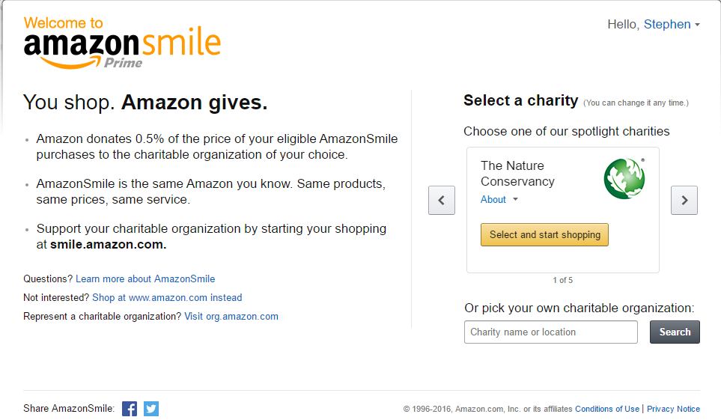
- Select the “Knights of Columbus Bishop of Pittsburgh Diocese Project”
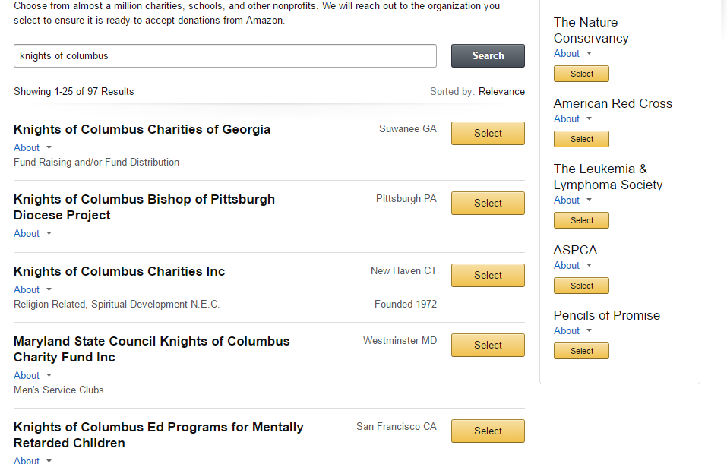
- Check the box and start shopping! So whenever you shop for anything on amazon, be sure to go to smile.amazon.com so that a portion of your purchase will go to the Knights of Columbus Bishop’s Project!

